Patient Diagnosis Report.

DESCRIPTION

The data analyst of a hospital wants to store the patient diagnosis reports with the details of the doctors and the patients for good medical practice and continuity of care.

**Objective:**

The database design helps to retrieve, update, and modify the patient’s details to keep track of the patient's health care routine.

**Task to be performed:**

1. Write a query to create a **patient’s table** with the fields such as date, patient id, patient name, age, weight, gender, location, phone number, disease, doctor name, and doctor id.

CREATE TABLE Patients (

Date DATE,

Patient_ID VARCHAR(20) PRIMARY KEY NOT NULL,

Patient_Name VARCHAR(100),

Age INTEGER,

Weight DECIMAL(5, 2),

Gender CHAR(1),

Location VARCHAR(100),

Phone_Number VARCHAR(15),

Disease VARCHAR(100),

Doctor_Name VARCHAR(100),

Doctor_ID INTEGER

);

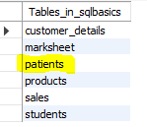

1. Write a query to **insert** values into the **patients table**.

INSERT INTO Patients (Date, Patient_ID, Patient_Name, Age, Weight, Gender, Location, Phone_Number, Disease, Doctor_Name, Doctor_ID)

VALUES

('2019-06-15', 'AP2021', 'Sarath', 67, 76, 'Male', 'chennai', '5462829', 'Cardiac', 'Mohan', 21),

('2019-02-13', 'AP2022', 'John', 62, 80, 'Male', 'banglore', '1234731', 'Cancer', 'Suraj', 22),

('2018-01-08', 'AP2023', 'Henry', 43, 65, 'Male', 'Kerala', '9028320', 'Liver', 'Mehta', 23),

('2020-02-04', 'AP2024', 'Carl', 56, 72, 'Female', 'Mumbai', '9293829', 'Asthma', 'Karthik', 24),

('2017-09-15', 'AP2025', 'Shikar', 55, 71, 'Male', 'Delhi', '7821281', 'Cardiac', 'Mohan', 21),

('2018-07-22', 'AP2026', 'Piysuh', 47, 59, 'Male', 'Haryana', '8912819', 'Cancer', 'Suraj', 22),

('2017-03-25', 'AP2027', 'Stephen', 69, 55, 'Male', 'Gujarat', '8888211', 'Liver', 'Mehta', 23),

('2019-04-22', 'AP2028', 'Aaron', 75, 53, 'Male', 'Banglore', '9012192', 'Asthma', 'Karthik', 24);

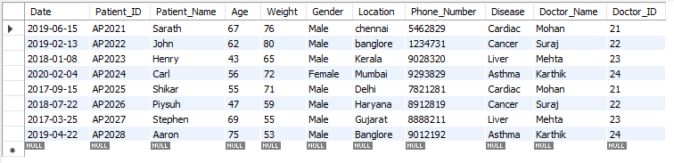

1. Write a query to display the **total number of patients** in the table.

SELECT COUNT(PATIENT_ID) AS 'Total Number of Patients' FROM PATIENTS;

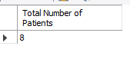

1. Write a query to display the patient id, patient name, gender, and disease of the patient whose **age is maximum**.

SELECT Patient_ID, Patient_Name, Gender, Disease

FROM Patients

WHERE Age = (SELECT MAX(Age) FROM Patients);

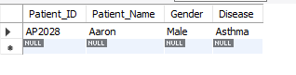

1. Write a query to display patient id and patient name with the **current date**.

SELECT Patient_ID, Patient_Name, CURDATE() AS 'Current_Date' FROM patients;

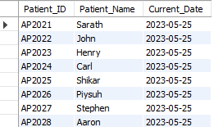

1. Write a query to display the **old patient’s name** and **new patient's name** in **uppercase**.

SELECT UCASE(Patient_Name) FROM PATIENTS;

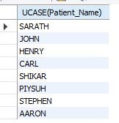

1. Write a query to display the patient’s name along with the **length of their name.**

SELECT PATIENT_NAME, LENGTH(PATIENT_NAME) AS PATIENT_LENGTH FROM PATIENTS;

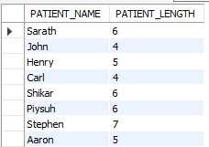

1. Write a query to display the patient’s name, and the **gender** of the patient must be mentioned as **M or F**.

UPDATE PATIENTS

SET Gender = 'F'

WHERE Gender = 'Female';

UPDATE PATIENTS

SET Gender = 'M'

WHERE Gender = 'Male';

SELECT Patient_Name, Gender FROM PATIENTS;

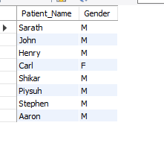

1. Write a query to **combine the names of the patient** and the doctor in a new column.

SELECT Patient_Name,Doctor_Name, concat(Patient_Name, '/', Doctor_Name) As 'Patient/Doctor' FROM Patients;

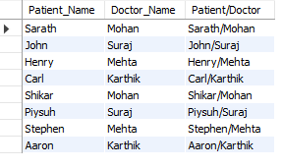

1. Write a query to display the patients’ age along with the **logarithmic value** (base 10) **of their age**.

SELECT Patient_Name, Age, LOG(10, Age) as Log_Age FROM Patients;

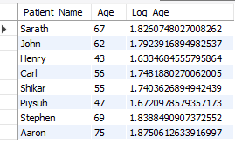

1. Write a query to **extract the year** from the given date in a separate column.

Select YEAR(Date) AS Patient_Year FROM PATIENTS;

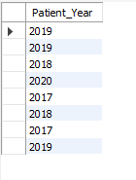

1. Write a query to return **NULL** if the **patient’s name and doctor’s name are similar** else return the **patient’s name**.

SELECT NULLIF(Patient_Name, Doctor_Name) AS Patient_Name FROM Patients;

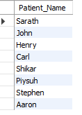

1. Write a query to return **Yes** if the **patient’s age is greater than 40** else return **No**.

SELECT Patient_Name, IF(Age > 40, 'Yes', 'No') AS AgeOver40 FROM Patients;

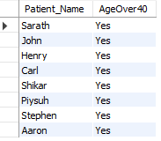

1. Write a query to display the **doctor’s duplicate name** from the table.

SELECT Doctor_Name

FROM Patients

GROUP BY Doctor_Name

HAVING COUNT (*) > 1;

